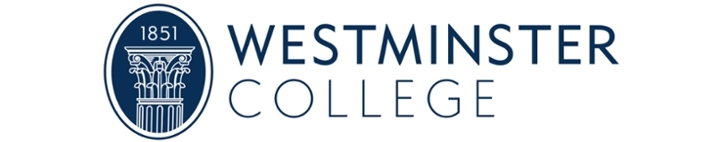

Proof of Funds Request
for Form I-20: Certificate of Eligibility

An international student must be able to prove they possess adequate resources to cover minimum annual expenses for the entire program of study at Westminster College. At this time, you are required to show hard evidence that funds are available to cover one year’s minimum expenses and moreover demonstrate or explain how sufficient funds will be available for the entire four years of the degree program.

Westminster College cost of attendance for 2026-2027:
Tuition and Fees  Living Expenses  Personal Expenses and Books | $39,278  $13,828  $3,000
Total: | $56,106

Required:
☐ Copy (or copies) of notarized bank statement(s) which must be in the applicant’s name or the name of a financial sponsor. Note: A “financial sponsor” is your source of financial support while you are studying in the U.S. A sponsor may be one or more family members or organizations.
- If the bank statement does not already include a copy of transactions over the past 3 to 6 months, please include separate official documentation that shows this information.

- The individual or combined balance must be an amount reasonably exceeding your balance owed to the College (your balance owed = total cost of attendance minus any scholarships or financial aid).
☐ Scholarship / financial aid letters (if from sources other than Westminster College)
☐ Letter(s) of Financial Support
- A letter of financial support outlines the expected funding that you will use to pay your balance at Westminster College. If you are personally providing funds, in whole or in part, for the costs of your education, you should write a statement describing your situation. Meanwhile, each financial sponsor should contribute a separate letter of support, also known as a letter of financial sponsorship.

The following are NOT accepted as proof of funds:
- Investment or property portfolios
- Paystubs or statements of income/salary
- Credit reports or credit card statements
- Statements regarding pension, life insurance, or tax returns

Please make certain that your bank statement:
☐ is notarized
☐ is on official bank letterhead, including the bank branch location and contact information
☐ is in English (or is accompanied by certified English translation)
☐ is recent: documents showing current balances must be dated within the past three months (prior to your submission to the Westminster College Office of Global Education Services)
☐ clearly indicates the account type (checking, savings, etc.)
☐ clearly states the accountholder’s name in English-compatible script
☐ clearly lists the currency of the funds in the account
☐ includes a currency conversion from the original currency to USD if the funds are not in U.S. dollars

Please make certain that your letter of financial support:
☐ is written by the accountholder of the notarized bank statement
☐ is in English (or is accompanied by English translation)
☐ is clearly dated (no earlier than the associated bank statement)
☐ is signed by hand
☐ includes valid contact information for the letter writer (email address and telephone number)
☐ states the relationship between the letter writer and the applicant
☐ confirms that, and explains how, costs will be covered not only for the applicant’s first year, but throughout the length of the degree program
☐ is notarized if not from an immediate family member (immediate family = parent/sibling/child/spouse)
☐ is notarized and on official letterhead if from a business, government institution, or other organization

Notes:
The Office of Global Education Services or Center for Admissions may still require additional proof of finances, identity, or relationship beyond these requirements.
If we are unable to verify the authenticity of your bank statement, we may require you to have it verified by a third party for an additional cost.

